Understanding HTTP with Wireshark
Objective: To identify and analyze unencrypted HTTP traffic.
Note: find any HTTP website at https://whynohttps.com/
Exercise 1: Identifying the Application Protocol
- Task: Capture traffic to an HTTP website.
- Guidance:
  - Start a Wireshark capture.
  - Visit an HTTP website in your browser.
  - Stop the capture after the page loads.
  - Filter the capture with http to see only HTTP traffic.
  - Look at the protocol column or the details of a packet to confirm it's HTTP.
Exercise 2: Observing the Domain and Full URL
- Task: Determine the domain and full URL from HTTP traffic.
- Guidance:
  - With the HTTP filter applied, select a packet that is a request to the web server.
  - In the packet details, find the Host header to identify the domain.
  - Look for the GET request line to see the full URL path.
Exercise 3: Data Traffic Visibility
- Task: Inspect the visibility of data in HTTP traffic.
- Guidance:
  - Find a packet containing a data payload (e.g., HTML content, form submission).
  - Examine the packet details to see the plaintext data.

Exercise 4: Exporting Images from HTTP Traffic
- Task: Capture HTTP traffic and export images (e.g., PNG, JPG) from the captured data.
- Guidance:
  - Capture HTTP Traffic:
    - Start Wireshark and begin capturing traffic.
    - Visit an HTTP website known to contain images.
    - Stop the capture after the page fully loads.
  - Filter HTTP Traffic:
    - Apply the http filter to narrow down the packets to HTTP protocol only.
  - Find and Export Objects: NOTE CAPTURE MUST BE STOPPED BEFORE THS IS AN AVAILABLE OPTION
    - Go to File > Export Objects > HTTP in Wireshark.
    - A window will pop up listing all the HTTP objects that Wireshark has captured, including images.
    - Browse through the list and look for image files by their MIME type (e.g., image/png, image/jpeg).
    - Select an image and click Save to export it. You can also select multiple images to export at once.
  - View Exported Images:
    - Locate the exported files on your computer.
    - Open them to view the images that were transmitted over HTTP and captured by Wireshark.

Before you begin this portion, make sure to fully read about the TLS handshake

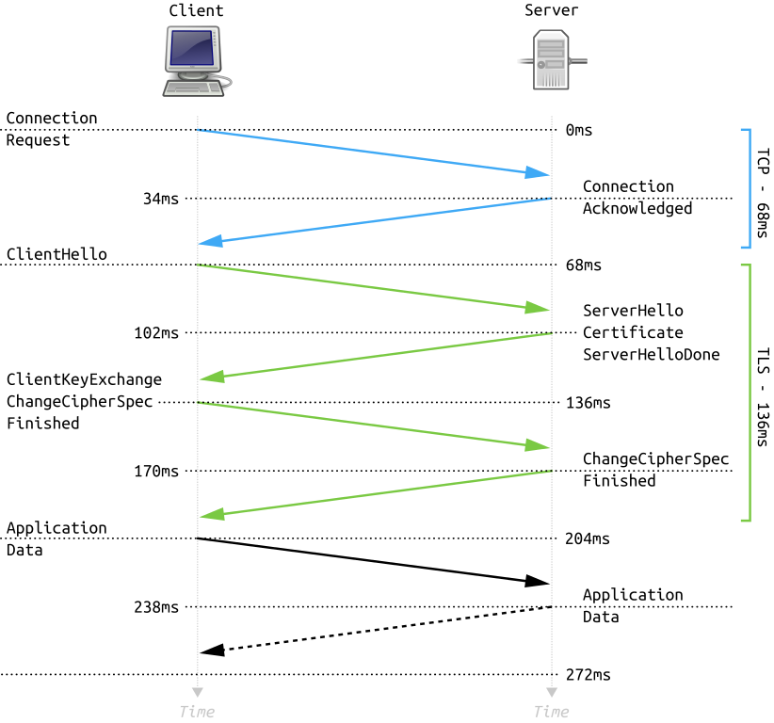
Image Source: Wikipedia
In the TLS handshake, the Diffie-Hellman key exchange occurs during the ServerKeyExchange and ClientKeyExchange phases. Here's how it fits into the TLS 1.2 handshake process:
- After the ServerHello message, if the server has chosen a cipher suite that requires a Diffie-Hellman exchange (like DHE or ECDHE ciphers), it will send a ServerKeyExchange message. This message contains the Diffie-Hellman parameters: a prime number, a generator (which is a base for modular arithmetic), and the server's public key (which is a number generated by raising the generator to a secret exponent modulo the prime).
- The client will then generate its own Diffie-Hellman public key using the same parameters and send this to the server in the ClientKeyExchange message.
- Both server and client will use their private numbers (which are not transmitted) and the other party's public number to compute the same secret shared key.
This shared key is then used to generate the encryption keys used for the session. The security of Diffie-Hellman comes from the fact that while it is relatively easy (computationally feasible) to generate the public key from the private key and parameters, it is extremely difficult (computationally infeasible) to reverse the process and derive the private key from the public key and parameters.

Understanding HTTPS with Wireshark
Objective: To analyze encrypted HTTPS traffic.
Exercise 1: Verifying the Application Protocol
- Task: Capture HTTPS traffic and identify the protocol.
- Guidance:
  - Start a new capture and visit an HTTPS website.
  - Stop the capture and apply a filter for tls or ssl.
  - Observe the protocol column to verify it's showing TLS/SSL, indicating HTTPS.
Exercise 2: Identifying the Domain
- Task: Locate the domain name in HTTPS traffic.
- Guidance:
  - Look for the Client Hello packet in the TLS handshake.
  - Find the Server Name Indication (SNI) within the packet details, which reveals the domain.
Exercise 3: URL Path and Data Traffic Encryption
- Task: Discuss the encryption of URL paths and data.
- Guidance:
  - Explain that the specific URL path and data are encrypted in HTTPS traffic, making them invisible in Wireshark.
  - Highlight the absence of readable HTML or form data in the packet details compared to HTTP.

Capturing and Comparing Handshakes
Objective: Understand the differences and similarities in the handshake processes of SSH, HTTPS, and WireGuard protocols.

Pre-Lab Setup
- Confirm access to an SSH server (for SSH handshake capture). You can use freeshell.org, sdf.org OR your own Linux VM.
- Choose a website using HTTPS for the HTTPS handshake capture.
- Use Cloudflare's WARP VPN service for capturing the WireGuard handshake.
Cloudflare’s WARP VPN can be found at https://1.1.1.1/

Exercise 1: SSH Handshake
- Task: Capture an SSH session initiation and observe the handshake.
- Guidance:
  - Start a Wireshark capture on the network interface used for internet access.
  - Initiate an SSH connection to a server.
  - Use the filter ssh in Wireshark to isolate SSH packets.
  - Observe and document the handshake process, noting the key exchange, algorithm negotiation, and session setup.

Exercise 2: HTTPS Handshake
- Task: Capture the initiation of an HTTPS session to understand the TLS handshake.
- Guidance:
  - Start another Wireshark capture.
  - Visit an HTTPS-secured website.
  - Filter captured traffic with tls or ssl.
  - Identify and document the TLS handshake steps, including the ClientHello, ServerHello, certificate exchange, and key establishment.

Exercise 3: WireGuard Handshake using Cloudflare WARP
- Task: Capture the handshake process of establishing a WireGuard VPN connection with Cloudflare's WARP service.
- Guidance:
  - Ensure Cloudflare WARP is installed and set up on a student device.
  - Begin a Wireshark capture, then connect to WARP.
  - WireGuard traffic can be more challenging to filter directly because it uses UDP and encrypted payloads. Look for UDP packets on the port used by WireGuard (usually 51820) as a starting point.
  - Discuss the observed handshake process, focusing on the initial exchange of public keys and the simplicity of the protocol compared to SSH and HTTPS/TLS handshakes.

